**GIT Department of Computer Engineering**

**CSE 222/505 - Spring 2022**

**Homework # Report**

**Student Name: Muhammed Alperen Karaçete**

**Student Number: 171044052**

1. **SYSTEM REQUIREMENTS**

Question1:

User:

Can add values to hash tables.

Can remove values from hash table.

Can look if table is empty or not.

Can get values from hash tables.

Question2:

User:

Must enter mod to choose numbers interval.

Must enter head and tail values for sort algortihms.

1. **CLASS DIAGRAM**

Question:1

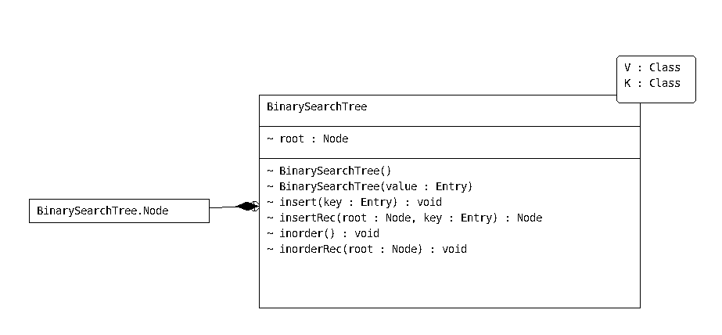

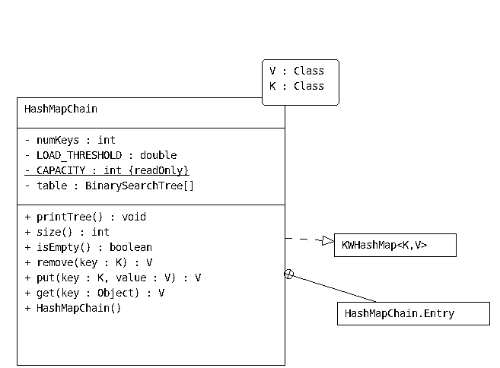

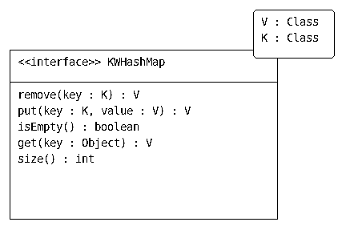

Question:2

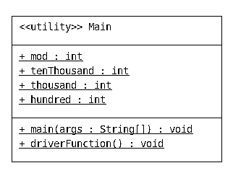

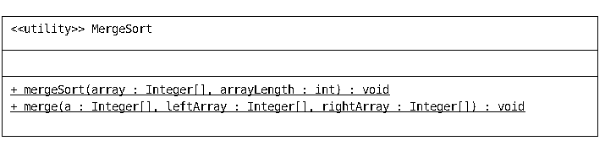

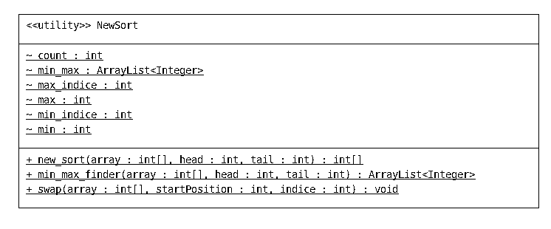

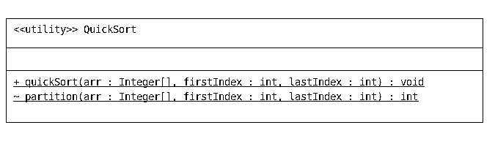

1. **PROBLEM SOLUTION APPROACH**

Question1:

Question2:

MergeSort:

Firstly I divide bigger array to two small arrays left and right.Each small array’s size is half of the big array.With recursion I repeated this operation.When I get smallest part, I call merge function.

With merge function until end of the both arrays,I compare every element

until end of the arrays.If left arrays value smaller than right, then hide it in the bigger array.Else, hide right array’s value in bigger array.At end, if there are any elements in left and right arrays, take values from left to bigger array,and then takes values from right to bigger array.

QuickSort:

Firstly choose a pivot.I choosed last element.While first index smaller than last index, Call partition function.Then call quicksort function two times.First call first element to pivot element, and then pivot element to last element.In partition function,from beginnig of the array until end of the array If choosen index smaller than pivot take its value to the left of pivot.If not change pivot’s value and bigger value.

NewSort:

In new sort class,min value is minimum value in the array,min indice is indice of min value in the array,max value is max value in the array,max indice is indice of max value,and count is hides information that how many times tail decreased and how many times head incremented.With that information I can control if all elements controled or not.In new_sort I found min indice and max indice with min_max finder function.Change positions of head indice with min indice and change position max indice with tail indice with swap function.Then cal recursive function again with incrementing head one and decrementing tail one.

1. **TEST CASES**



1. **RUNNING AND RESULTS**

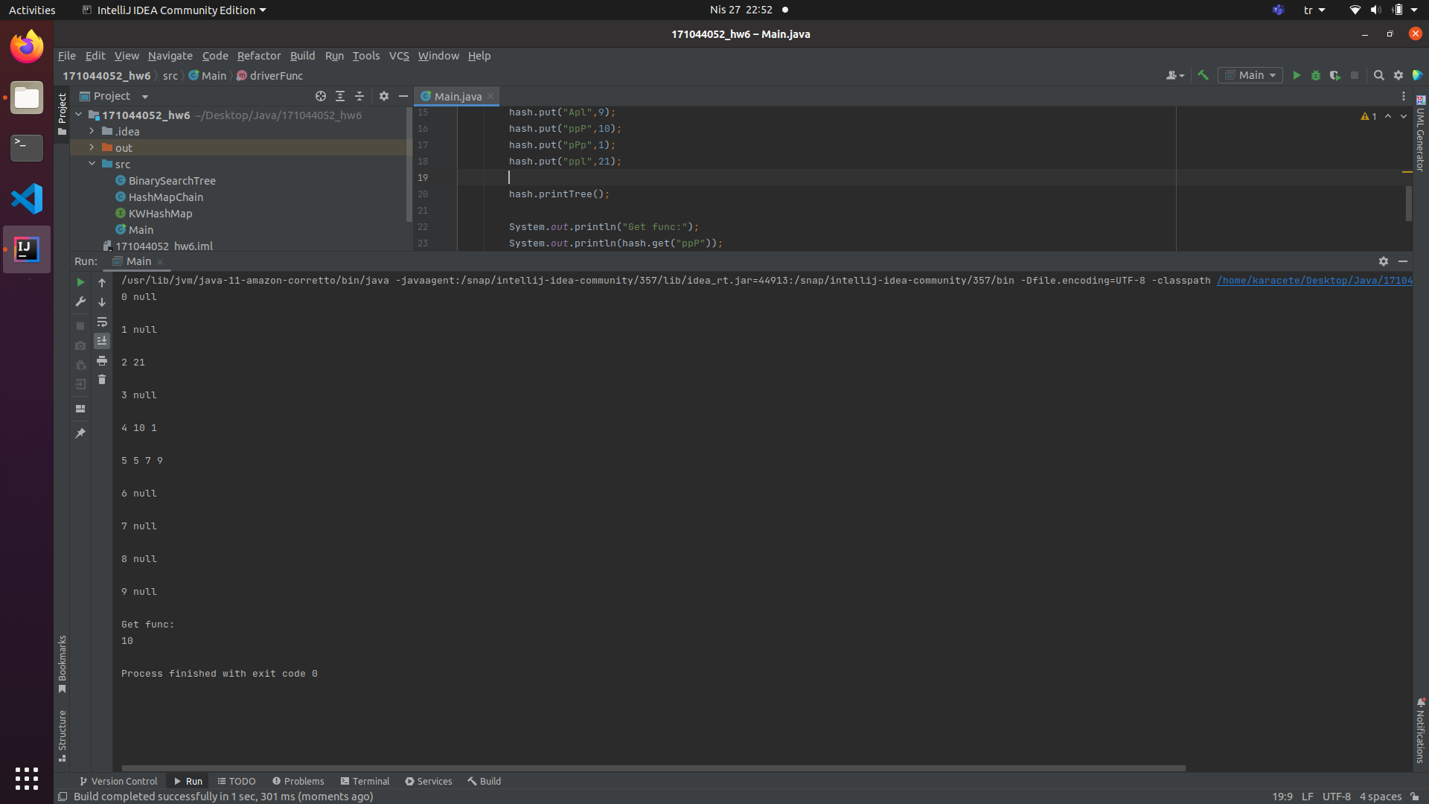Question1:

Question2:

MergeSort:

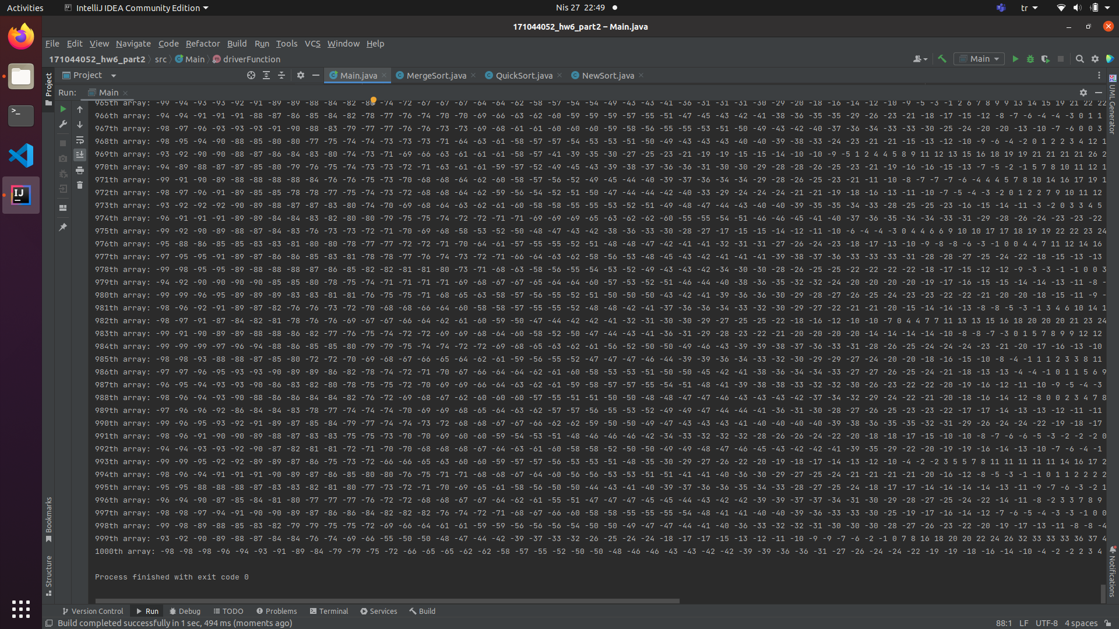

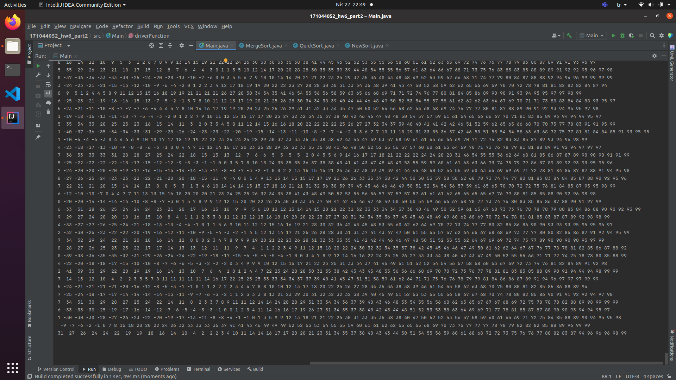

NewSort:

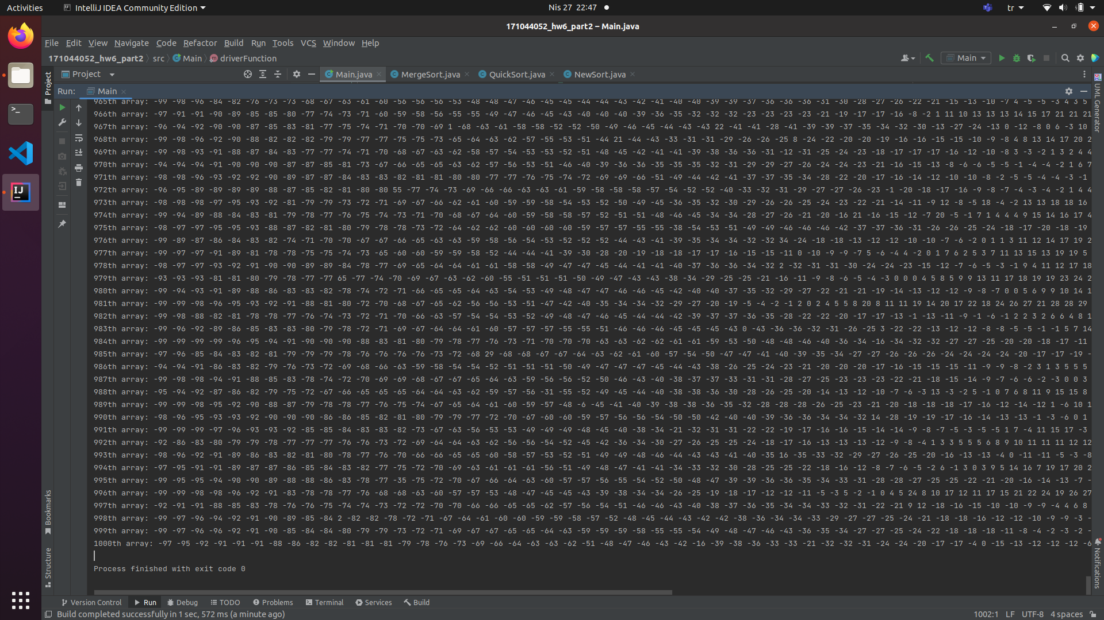

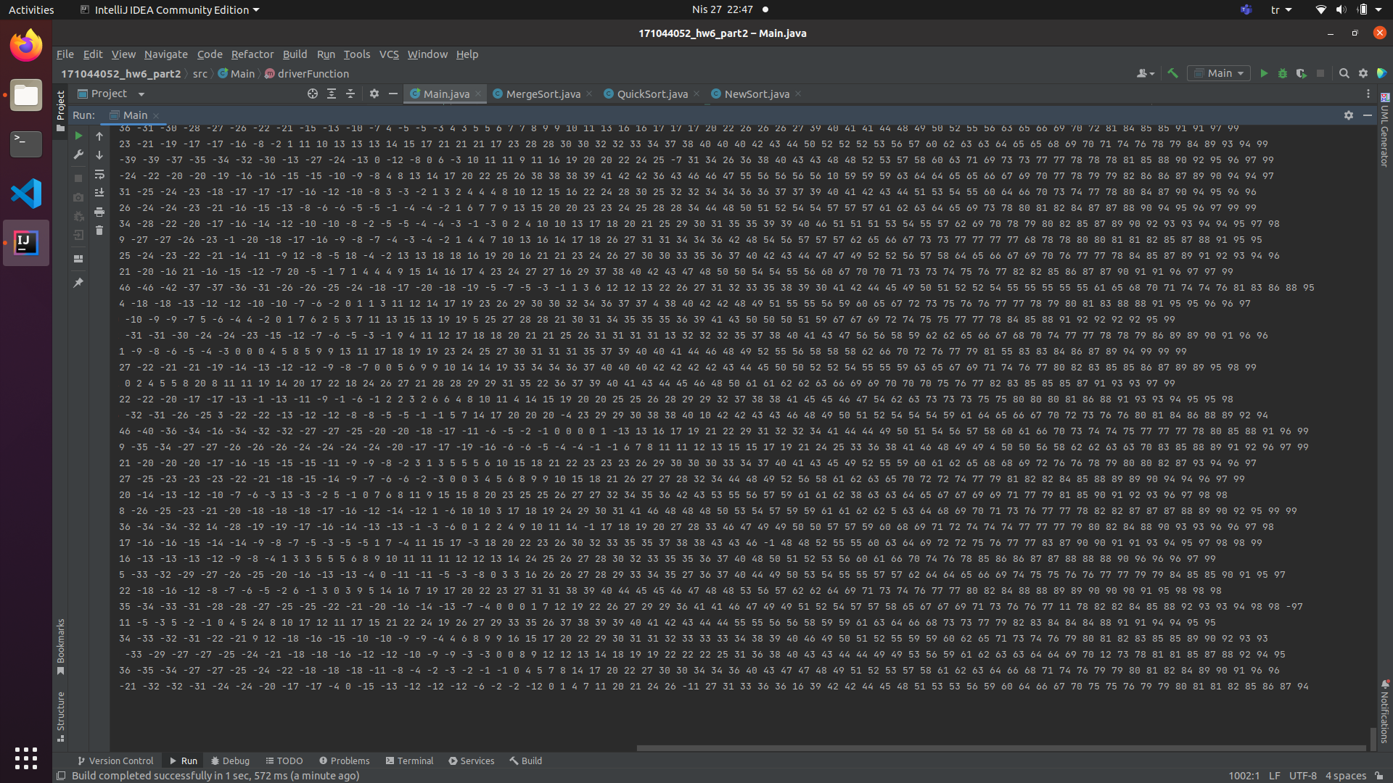

QuickSort:

